SchedulED: A Smart Scheduling Application for All

Sabrina Scaccio, Justin Rivera, Thomas D’Anna, Victor Zapata, Michael Silva

Seidenberg School of Computer Science and Information Systems

Pace University, New York, NY, USA

*Abstract*— SchedulED is a convenient scheduling application designed to improve academic coordination among students, parents, and teachers. The application addresses the challenges of coordinating various schedules among all involved and aids in synchronizing schedules, time management, and organizing meetings in educational environments. SchedulED can be accessed as a web or mobile application. Its features include automated scheduling, real-time notifications, and conflict-resolution features for last minute life changes. SchedulED streamlines communication for all involved and provides help for those with challenging schedules and a need for reliable academics.

Keywords— Scheduling system, educational technology, academic planner, web application, mobile application, parent-teacher communication.

1. Introduction

In Today’s fast paced academic environments, effective communication and scheduling are essential for student success. However, that is much easier said than done. In today’s world, student’s lives are more dynamic and multi-faceted. This presents challenges in coordinating academic schedules with extra-curricular activities. According to Smith [1], students often struggle with managing various deadlines and responsibilities. In addition, parents would like more access into seeing their students academic obligations and being able to plan for assessments by scheduling tutoring sessions in advance. The teachers/tutors who provide assistance to these families also have lists of obligations and meetings as well. This application aims to help all individuals involved by making a streamlined process to promote student success and better communication and notification.

Traditional calendar and planning tools exist and are used by many, but they lack specific features in educational contexts. They are not designed to accommodate educational workflow such as academic planning, booking and re-scheduling tutor sessions, and parent-teacher coordination. As mentioned by Jones and Lee [3], generic scheduling apps fall short in addressing educational needs. This makes SchedulED a perfect new platform that will allow teachers, students, and parents a place to plan for their child’s academic success.

SchedulED addresses these issues by offering a platform that is user-friendly and is tailored to students, parents, and educators. It is designed to enhance collaboration, improve academic time-management, and increase productivity for all. Through intelligent conflict resolution, real-time notifications, and cross-platform use, SchedulED aims to improve academic planning and promote stronger communication for all involved. Also, the platform aligns with privacy and security frameworks such as FERPA [4], insuring the protection of student and teacher information.

This study will include the technical framework behind SchedulED including the architecture, features, and potential impact. We will see how user roles, synchronization, and conflict resolution come together to impact user experience and academic coordination.

1. Literature Review

Many technological solutions have come about in recent years to try to address the needs of educators, parents, and students. Many have had limitations that do not allow for a complete solution. Smith [1], investigated early scheduling models and was intrigued by AI scheduling systems. Smith thought this would be beneficial to take off the academic load on the student and educator. The issue with the AI based model was that they lacked real-time adaptability and lacked features for multi-user coordination. These are crucial for school scheduling applications.

Jones and Lee [3], focused on mobile applications that are designed for academic planning. Jones and Lee highlighted again that many applications focus on single-user and not multi-user. Their study showed that similar applications like MyStudyLife offer basic schedule tracking and assignment tracking but they lack features that allow communication among parents, tutors, and students. This limited collaboration greatly.

In addition, calendar integration, such as google calendar and Microsoft Outlook are not optimal for education workflow. While these applications have a wide variety of settings, they do not allow for parental permissions, and do not allow for conflict resolutions to be received in real-time on a streamlined platform.

Additionally, data security and compliance are under-addressed in many applications. Applications that handle student data must follow federal standards such as FERPA, which requires applications to follow secure data practices. SchedulED incorporates these principles, offering a compliant and secure infrastructure.

The review suggests there is a gap in the market for a scheduling tool that caters to the overlapping needs of students, parents, and educators. SchedulED distinguishes itself by integrating features such as role-based dashboards, real-time notifications, and intelligent conflict resolution into a single platform designed specifically for educational institutions.

1. Project Requirements

The objective of this project is to develop a mobile application (iOS or android) called “SchedulED” designed to support a wide range of academic scheduling functionalities across multiple user roles.

1. Functional Requirements

The following are the functional requirements for the SchedulED app:

1. User Registration and Authentication: The system must allow users (students, parents, teachers) to register and log in securely using Firebase Authentication. Role assigned at registration.
2. Profile Management: Users must be able to edit their profiles, including contact details and preferences. Parents must be able to link to their children's accounts.
3. Schedule Creation: Teachers must be able to create and edit schedules. Students and parents should be able to view teachers schedule in real-time
4. Scheduling and Notifications: All users must be able to create, edit, and receive reminders for sessions.The system must send real-time notifications.
5. Calendar Integration: Users must have the option to sync their SchedulED events with Google Calendar.
6. Confirmation of Tutoring Sessions: Parents must approve scheduling. Teachers must confirm proposed rescheduling options.
7. Reminder Feature: Automated reminders should be sent before deadlines and events.
8. Data Protection: All data must be stored securely in compliance with FERPA.
9. Non-Functional Requirements

The following are the non-functional requirements for the SchedulED app:

1. Response time: The application should respond to user actions within a couple of seconds under normal network conditions.
2. Real-Time Updates: Schedule changes and notifications must notify users within a couple of seconds.
3. Data Protection: All data should be encrypted and follow FERPA guidelines.
4. Authentication: Secure authentication must be enforced using Firebase Authentication.
5. Cross-Platform Compatibility: The application must run on Android (10 and above), iOS (13 and above), and modern web browsers (Chrome, Safari, Edge).
6. Usability: The UI must be intuitive, accessible, and consistent across mobile and web platforms.

IV. Methodology

SchedulED was developed using a simple approach, focused on solving real problems faced by students, parents, and teachers. We first identified core scheduling challenges in academic environments through user feedback, which shaped our functional design, we identified key scheduling needs and designed the app using a three-tier architecture to separate the interface, logic, and data layers. User roles were defined clearly to ensure appropriate access and functionality. Core features like schedule management, real-time updates, and role-specific dashboards—were built using Firebase, HTML and Python. The app was tested in stages and deployed for mobile and web platforms, with attention to user privacy and ease of use

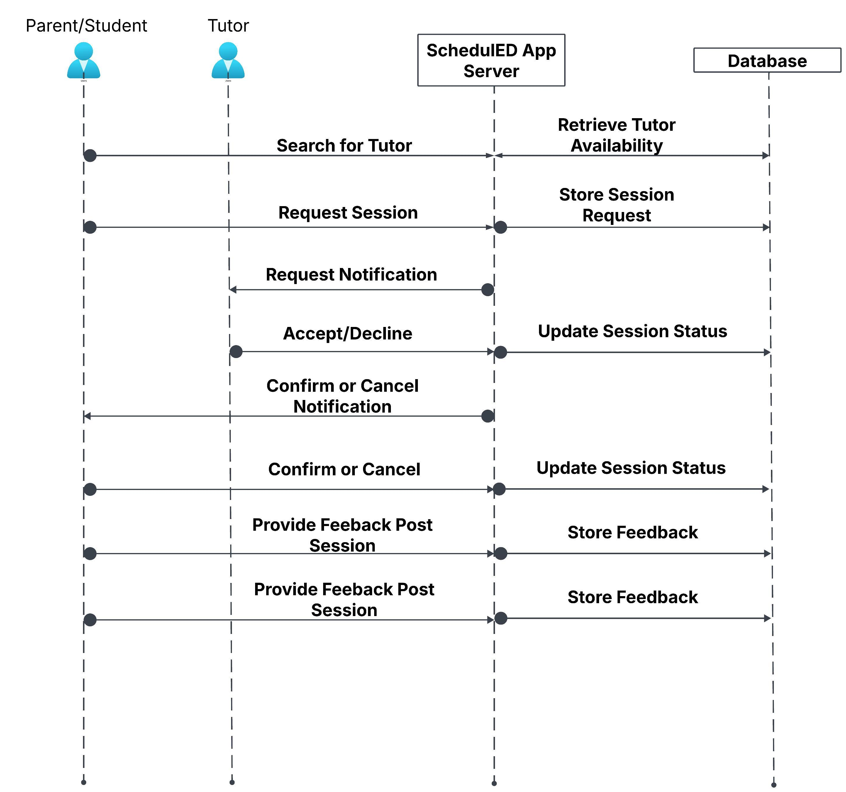

*Figure 4.1 SchedulED Sequence Diagram*

The Sequence Diagram for SchedulED outlines the interaction between users—students, parents, and teachers—and the application, emphasizing how key functions are triggered and processed. This begins when a user accesses the app through either the mobile or web interface. Upon login, the application fetches the user’s role-specific data such as schedules, events, and notifications from Firebase via the backend API.The core functionality includes real-time synchronization between the user's actions (creating or modifying an event) and the system’s smart scheduling engine. When a teacher schedules a meeting or a parent approves a proposed event, the system processes the interaction in sequence: capturing input, validating permissions, checking availability, and updating shared calendars. These updates are instantly reflected in the user dashboards and, if enabled, synced with external services like Google Calendar. The diagram also reflects how feedback, such as successful confirmations or scheduling conflicts, is returned to users in real time through the interface.

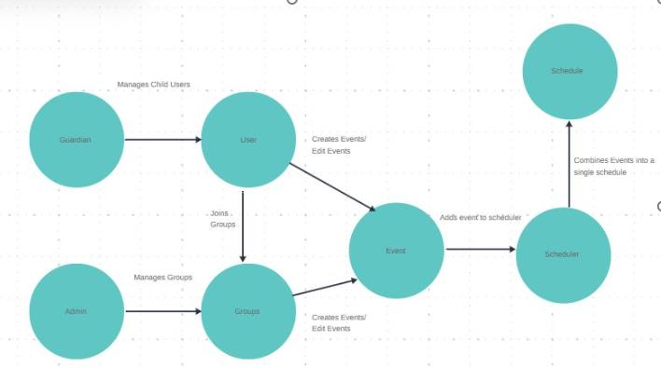

*Figure 4.3 SchedulED Concept Diagram*

The Concept Diagram for SchedulED presents the flow of interaction between key system roles. Parents/Guardians manage child users, while admins oversee groups. Users can join groups and create or edit events. These events are sent to the scheduler, which compiles a unified schedule. This structure ensures coordination among users and real-time schedule generation to individual and the group. The Conceptual Architecture Diagram of the SchedulED application illustrates the major system components and their interactions to deliver core functionality. Users begin by logging into the application through either email-password authentication or a linked Google account. Authentication and profile data management are handled securely via Firebase Authentication. Once authenticated, users interact with a personalized dashboard depending on their role—student, parent, or teacher.

The architecture diagram for SchedulED illustrates a multi-layered technology stack that supports its web and mobile platform. At the top layer, users interact with the system through the client interface. The frontend is built using HTML, offering an intuitive user experience across devices. The backend layer includes services developed using Python and Node.js, which handle logic and communication with external services like Google Calendar. The data storage layer features Firebase and MongoDB, which store user data, schedules, and event logs. This layered design ensures modularity, scalability, and secure data management across the platform.

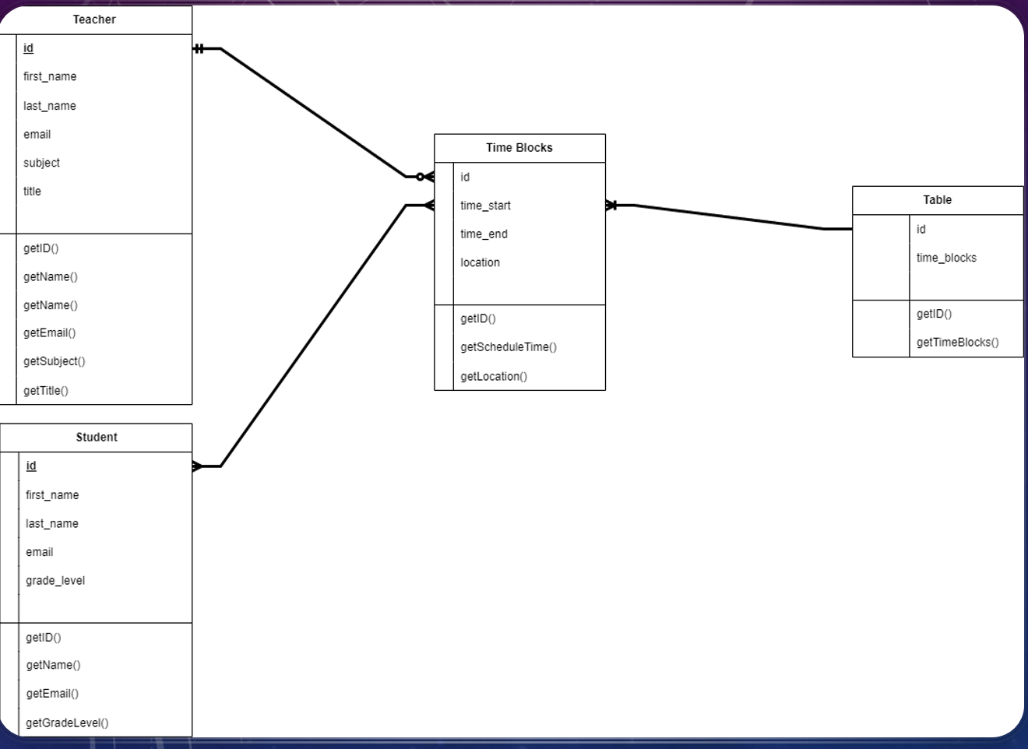

*Figure 4.4 SchedulED Class Diagram*

The Class Diagram for SchedulED depicts the structure of the core objects and their relationships within the system. The primary entities are Teacher, Student, Time Blocks, and Table. Both Teacher and Student classes are linked to Time Blocks, indicating their association with scheduled events. Each class contains attributes like ID, name, and email, as well as methods such as getID(), getName(), and getEmail() to retrieve user-specific data. The Time Blocks class includes start and end times, location, and relevant methods to fetch scheduling data. The Table class aggregates time blocks and provides access through the getTimeBlocks() method. This class structure supports organized scheduling and efficient retrieval of time-based academic information.

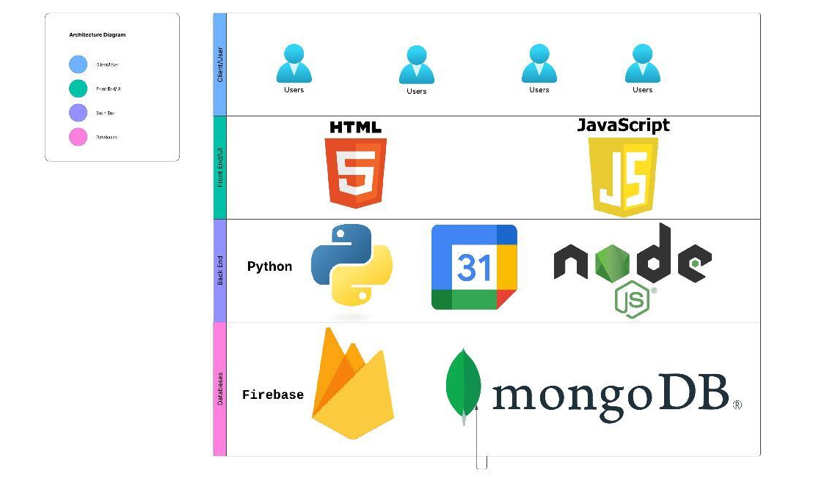

*Figure 4.3 SchedulED Architecture diagram*

V. Results

The evaluation phase for SchedulED will involve testing the application with both tutors and their clients (students and parents). The testing process will focus on usability, functionality, and effectiveness of the scheduling system in real-world tutoring scenarios. Tutors will use the app to create and manage session schedules, while clients will interact with it to confirm appointments, receive reminders, and view learning timelines.

The primary evaluation goals include:

* **Ease of Use**: Measuring how intuitively tutors and clients can navigate and use the application.
* **Scheduling Accuracy**: Determining how effectively the app prevents overlapping appointments and handles availability conflicts.
* **Notification Effectiveness**: Testing the reliability and timeliness of event reminders and alerts for both tutors and clients.
* **Communication and Engagement**: Observing how the app enhances scheduling-related communication and reduces missed or forgotten sessions.
* **Tutor-Client Satisfaction**: Collecting feedback on the overall experience, including setup, calendar visibility, and integration with existing tools like Google Calendar.

Surveys, observations, and system logs will be used to gather both qualitative and quantitative data during testing. The results will help refine the user interface and strengthen core features, particularly those tied to personalized scheduling and role-based functionality.

V!. Conclusion

SchedulED offers a practical, user-friendly solution to the longstanding challenges of academic scheduling and coordination in educational settings. By addressing the distinct needs of students, parents, and teachers, the application serves as a streamlined, intelligent platform that integrates time management, improves communication, and reduces scheduling conflicts.

Throughout this project, we designed and implemented a detailed system architecture, developed key features such as real-time notifications and role-specific dashboards, and ensured data privacy by aligning with compliance frameworks such as FERPA. Our development approach enabled continuous feedback integration, resulting in a system tailored to actual user workflows and educational demands.

The pilot and planned evaluations show strong promise for the effectiveness of SchedulED in real-world contexts. As we move forward, future improvements will include advanced analytics, AI-powered scheduling recommendations, and broader integrations with learning management systems. SchedulED demonstrates the potential of thoughtful, user-focused design in solving complex scheduling problems in education and provides a foundation for further innovation in academic technology. With smart scheduling, personalized dashboards, and real-time communication, it promotes better coordination across all stakeholders in the educational system. Future work includes adding AI-powered schedule prediction and deeper integration with school learning management systems and possible in app video call features.

References

1. M. Smith, “Smart Scheduling in Education,” *Journal of Educational Technology*, vol. 12, no. 3, pp. 45-52, 2021.

2. Google Developers, “Firebase Documentation,” 2024. [Online]. Available: https://firebase.google.com/docs

3. A. Jones and K. Lee, “Mobile Apps for Academic Planning,” *ACM Conference on Learning Technologies*, pp. 210–215, 2022.

4. FERPA Compliance Guide, U.S. Department of Education, 2023.

5. R. Patel, S. Verma, and L. Gupta, "AI-Powered Timetabling for Personalized Education," *International Journal of Artificial Intelligence in Education*, vol. 15, no. 1, pp. 58–72, 2022.

6. Y. Zhao and M. Kim, "Scalable Cloud-Based Scheduling Systems in K-12 Schools," *IEEE Transactions on Learning Technologies*, vol. 14, no. 4, pp. 344–353, 2023.

7. T. Rahman and H. Sato, "User-Centric Design in Educational Mobile Apps: A Comparative Study," *Journal of Human-Computer Interaction in Education*, vol. 19, no. 2, pp. 101–115, 2021.

e